ARCHITECTURAL DESIGN II
Project 2: Addition to an Existing Order

An addition to an existing order, "requires first that the ordering system of the prior or prototypical model be perceived and understood so that, through a series of finite changes and permutations, the original design concept can be clarified, strengthened, and built upon, rather than destroyed."
Francis D.K. Ching, Architecture: Form, Space & Order

PROGRAM:
The Smith Family has commissioned you to design an addition to their house on the shore of Long Island Sound. The original house, designed in 1965 by architect Richard Meier, has been widely published and is internationally known. Unfortunately, the Owners needs have change since the original design, thereby warranting this architectural intervention. The Owner specifically request that the integrity of the original design be respected, yet the new addition should have its own presence.

This is a project that focuses on the fit of three dimensional massing and ordering systems as the design generator in the context of existing forms and three dimensional systems. Extruded existing systems is a design starting point.

REQUIREMENTS:
- Master Suite, (duplex arrangement)
- Master Bedroom, 200 S.F.
- Master Bath, 80 S.F.
- Walk-in-closets, as required
- Exercise Room, 180 S.F. (not on same floor as bedroom)
- Family Room, 300 S.F.
- Formal Outdoor Area, 300 S.F. (i.e. deck, roof garden, etc.)

METHOD/PROCESS OF DESIGN
IDEA FORMATION => DIAGRAM => 3-D ARCH.

IDEA FORMATION:
A. PROGRAM (NEED)
- list of room area requirements
B. NARRATIVE (VALUE)
- story
- rank / hierarchy
- sort
C. CONTEXTUAL ANALYSIS (EXISTING PATTERNS):
- EXISTING 3-D ARCH => 2-D SYSTEMS DIAGRAMS => UNDERSTAND CONTEXT
- Incorporate into idea formation
- Becomes the reverse of the design process
D. ANALYSIS OF SYSTEM DIAGRAMS:
Draw a diagram for each floor plan and then a final composite diagram.
Diagrams should be as reductive as possible and not look like floor plans!!!
- circulation (lines)
- hierarchy
- enclosure (areas)
- structure (lines)
- additive and subtractive (areas)
- mass/void (areas)
- function (areas)
  - Public / Private
  - Sleeping / Living
CONCEPTUAL ANALOGIES FOR ADDING ON
- Joint
- Hinge
- Reveal
- Peg
- Chord/Bridge (WEAK)
- Shift
- Geometric proportions
- Geometric rotations
- Flush or Butt Joint (AVOID)
How does one add on without destroying the existing building or replicating an outdated building?

SYSTEMS TO EXTRUDE INTO NEW ADDITION (interlocking fingers analogy)
- extrude 2 or 3 systems / patterns into the new addition
- extend systems and patterns into the existing building

METHOD/PROCESS OF DESIGN AFTER ANALYSIS, NARRATIVE, CONCEPTUAL CONNECTION are established
- EXISTING 3-D ARCH MODEL => SYSTEMS DIAGRAMS in 2-D =>
- Select 2 to 3 existing SYSTEMS DIAGRAMS in 2-D to extrude in 3-D on the EXISTING MODEL as a conceptual framework for interacting with the new addition
- Design 3-D MASSING MODEL for FIT/SCALE, IDEA, HIERARCHY
- Draw 2-D floor plans for based on 3-D MASSING MODEL to check function (reality check)
- Extend a New System (element) into Existing MODEL for tie in beyond the conceptual connection
- The Floor Plans are to be diagrammatic, don't draw real doors and windows at this point.
- Convert the diagrammatic floor plans to spaces based on the 3-D MODEL.

Bibliography:
Francis Ching, Architecture: Form, Space & Order

PROCEDURE
WEEK ONE: Teams:
Analytical diagrams of systems:
- circulation
- hierarchy
- enclosure
- structure
- additive and subtractive
- mass/void
- function
Convert drawings to CAD
- Lower, entry and upper levels
- Site Plan
- Elevations, all four
WEEK TWO: Individual:
- Sketch model of existing
- Preliminary design:
- diagrams and ideas
WEEK THREE:
- Floor plans, elevations, axonometric
- Layout web page
WEEK FOUR:
Presentation Requirements
Contextual Fit: Analysis & Design of Adding on
Project Due date: __________ at start of class on the WEB
Internet Presentation format:
Contextual analysis
- Existing building systems (6+ diagrams)
Conceptual Ideas
- Hierarchy (from narrative, rank and sort) & Meta Idea (if needed)
- Conceptual connecting analogy (2-D & 3-D sketches)
- Existing systems to be used or extruded into new building
- Proportion out new functions
- New Systems to be brought into existing building

Preliminary Designs
- 3-D ideas (as needed)
Final Design
- Plans (3)
- Elevations (4)
- 3-D exterior (4)
- 3-D interior (2)
- Section (2) new + existing (an Auto CAD command does this automatically
- Animation (2) (if needed showing new with existing)

Please do not show only the new addition without the existing context (includes building & site)!
All students must present a project from their website as part of the submission. No late projects accepted!

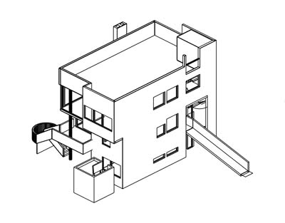

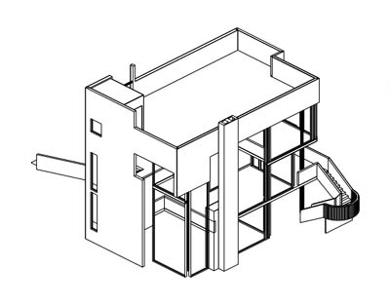

Richard Meier & Partners Architects LLP
- Projects
- Practice

Smith House
Darien, Connecticut
1965 - 1967
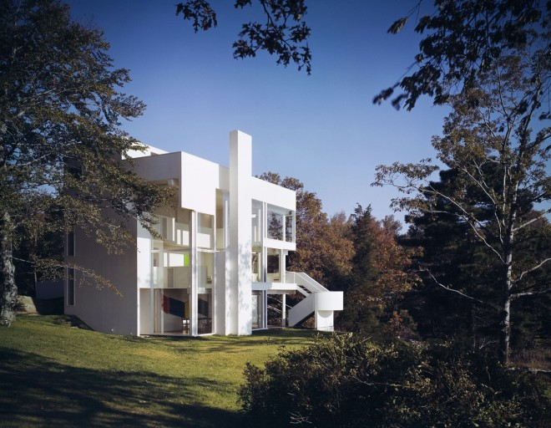
The Smith House, built amidst the rocks and trees of a one-and-a-half-acre site, overlooks Long Island Sound from the Connecticut coast. A dense cluster of evergreens stands at the entrance to the property. Behind, the land clears and rises to the center of the site, then drops sharply to the rocky shoreline and a small, sandy cove.
The spatial organization of this house hinges on a programmatic separation between public and private areas. The private side of the house is at the entrance facing land, woods, and road. A series of closed, cellular spaces, these private areas are organized through three levels behind an opaque façade, which is intermittently pierced with windows. The public spaces, where the family meets and entertains, are to the rear of the house, overlooking the water. This public sector consists of three levels nestled within a three-sided glass enclosure; from the outside, the ground and upper levels appear as solid slabs held fast in the white mullions of the glass shell.
The dramatic view of sea and sky that greets one upon entering is framed and intensified in the transparent skin of the rear façade. Placed directly opposite the entry, a painted brick fireplace pushes to the outside through the tight frame of mullions. Suspended between the chimney and the steel structural columns, the glazed wall creates a subtle tension that draws the occupant across the living space to the outside. The balustrades of the lower and upper levels are set back from the glass, amplifying that tension.
As a camera records the moment of an event, the experience of changing light and weather activates the crisp surfaces of the house, while the clear glazing gathers subtle reflections of the interior across its surface. The natural and the manmade exist as separate, elemental experiences, yet it is impossible to separate one from the other.

- 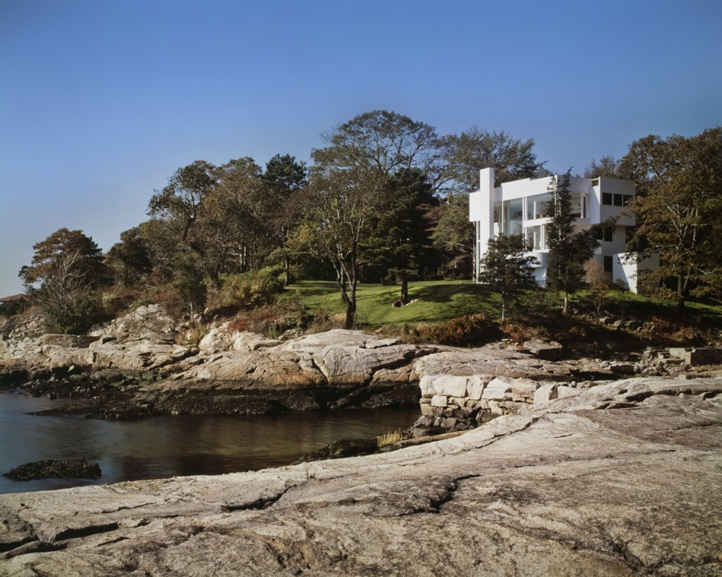
- 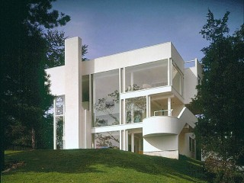
- 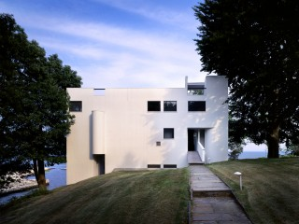
- 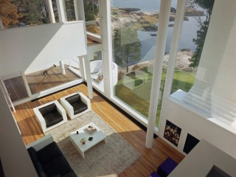
- 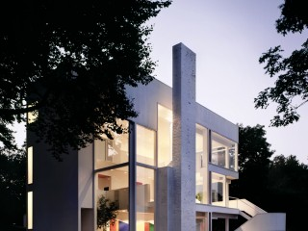

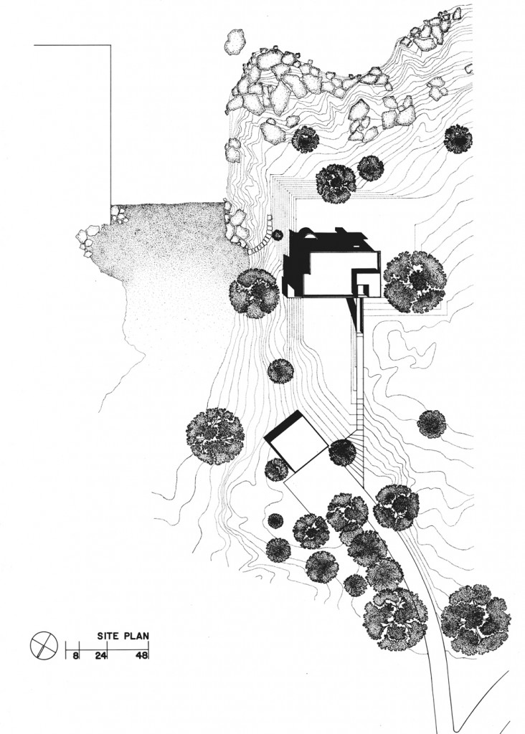
- 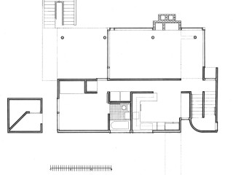
- 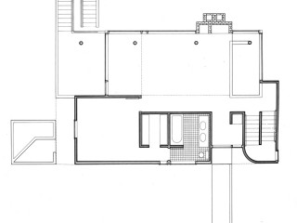
- 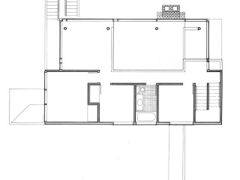
- 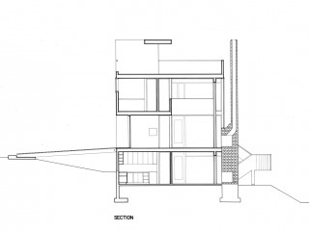
- 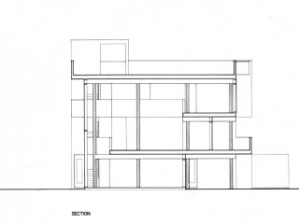

Credits
- Building Photography:
Scott Frances

Related
Partner

Richard Meier
Richard Meier & Partners Architects LLP
